**Checking Ubuntu OS Version**

1. Open a new Terminal:

* Click the Activities button (top left corner) and search for "Terminal."
* OR, press **Ctrl + Alt + T** on your keyboard to open new terminal.

2. Run the Command:

* In the terminal window, type the following command:

**lsb_release -a**

This command stands for **"Linux Standard Base release information - all."** It fetches details about your system's distribution and version.

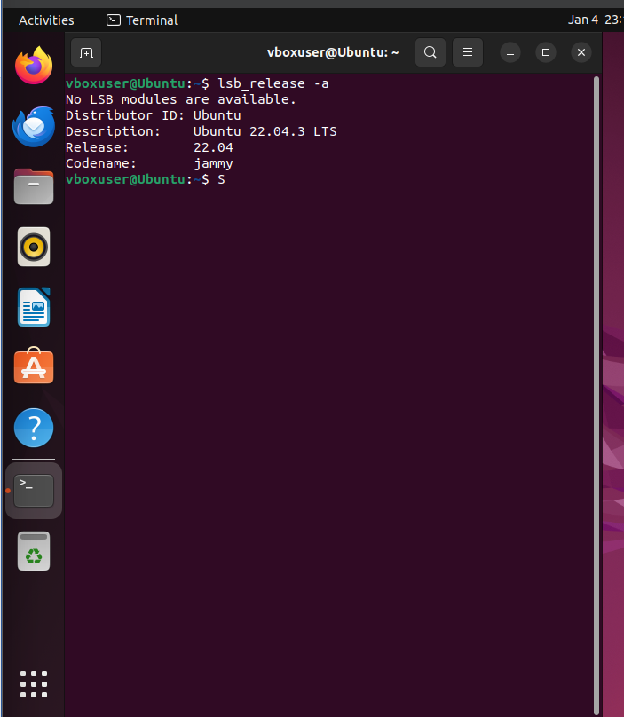

3. Output:

Press Enter and you'll see a short textual output like this:

**Distributor ID: Ubuntu**

**Description: Ubuntu 22.04.3 LTS**

**Release: 22.04**

**Codename: jammy**

Each line explains a specific aspect of your Ubuntu:

* Distributor ID is used confirm that you're using Ubuntu.
* Description tells you the exact version, including the Long Term Support (LTS) status if applicable.
* Release shows the version number again.
* Codename provides a quirky internal codename for the version.